
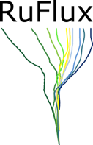



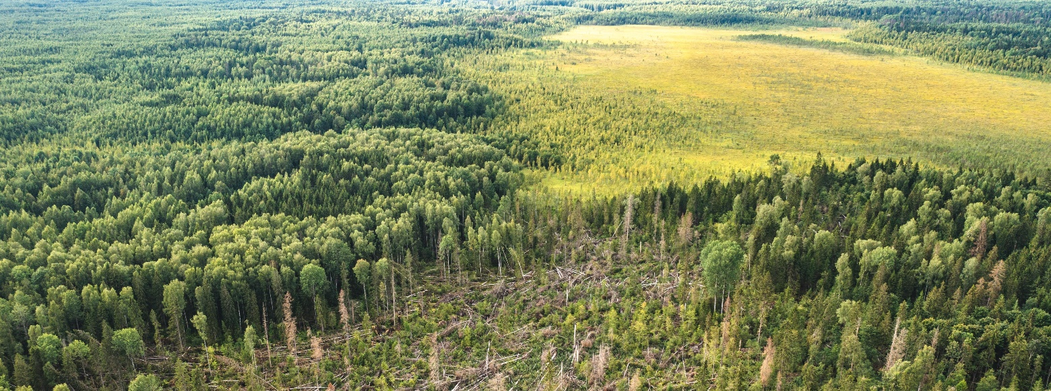
International Conference and Summer Field School
"Greenhouse Gas Fluxes: Key Trends in Modern Research"
August 12–20, 2026
2nd Circular Letter
A.N. Severtsov Institute of Ecology and Evolution of the Russian Academy of Sciences (IEE RAS)
Central Forest State Nature Biosphere Reserve
Lomonosov Moscow State University (MSU)
National Research University Higher School of Economics (HSE)

Dear Colleagues!
Rapid modern climate changes impact the structure and functions of the biosphere, which in turn affect the climate through biogeochemical and biogeophysical processes. The study of these bidirectional relationships is a long-standing subject of research and collaboration among many scientific teams in Russia and abroad. The A.N. Severtsov Institute of Ecology and Evolution of the Russian Academy of Sciences (IEE RAS) kindly invites you to participate in the international conference, organized by IEE RAS (Moscow) on August 12–20, 2026. As a part of the conference, the summer field school will take place at the IEE RAS South Valdai Ecological Observatory "Okovsky Forest," a field station located in the Central Forest State Nature Biosphere Reserve (Tver Region, Nelidovsky District, Zapovedny settlement). The conference aims to facilitate the exchange of experiences in measuring and interpreting data on greenhouse gas fluxes. The program includes visits to four eddy covariance stations in ecosystems typical of the southern taiga in European Russia: a sphagnum-bilberry spruce forest, a mixed spruce-broadleaf forest, the Staroselsky Mokh oligotrophic bog, and a clearcut area in a mixed spruce forest. More than 25 years of research by the team of the V.N. Sukachev Laboratory of Biogeocenology at IEE RAS in the Central Forest Reserve will be presented in lectures, practical workshops, and excursions during the summer field school. Leading scientists from research teams across the country who study greenhouse gas fluxes in European Russia and Siberia will give lectures and master classes. The practical sessions will include the application of both the eddy covariance and chamber methods for studying greenhouse gas fluxes. The school aims to disseminate comprehensive knowledge and skills in studying greenhouse gas exchange in the context of climate change. It will be particularly useful for staff of carbon supersites, as well as for members of the academic and business communities professionally involved in decarbonization and nature-based climate solutions. The total number of participants for the excursions and the School is limited by the accommodation capacity of the Reserve's facilities.
Conference and school website with all organizational information and a web-link to a registration form:
https://fluxes2026.sev-in.ru/en
Alternative link: https://fluxes2026.github.io/en

The program of the conference and the school
August 12–13 – Conference "Greenhouse Gas Fluxes: Key Trends in Modern Research" (A.N. Severtsov Institute of Ecology and Evolution, Russian Academy of Sciences, Moscow, Leninsky Prospekt, 33)
August 14 – Transfer by bus of Conference and School participants to the Central Forest Reserve (Tver region, Nelidovsky district, Zapovedny settlement; about 350 km northwest of Moscow; travel time is approximately 6 hours)
August 15 – Field seminar in the Reserve with an excursion to four eddy covariance sites (distance 4-7 km from the central estate, part of the journey by transport) and an ecological trail through typical southern taiga landscapes of the Reserve. Welcome dinner.
August 16 – Transfer by bus to Moscow for Conference participants not staying for the field school.
August 16–19 – School participants stay in the Reserve, attending lectures, seminars, and conducting field research.
August 20 – Transfer by bus of School participants to Moscow

Key dates:
First Information Letter | February 5, 2026
Second Information Letter | March 10, 2026
Registration | Until May 1, 2026
Abstract Submission | Until May 15, 2026
Conference Program | July 15, 2026
Participant Arrival | August 11–12, 2026
Payment of Registration Fee | August 12, 2026
Participant Departure | August 20–21, 2026

Information about Conference
The conference will include the following sections:
1. Results of ecosystem-scale greenhouse gas flux measurements
2. Spatial scaling of estimates of greenhouse gas fluxes
3. Chamber methods in greenhouse gas research: methodological issues and monitoring results
4. Modeling of greenhouse gas fluxes
A round table is planned on the topic: "Using measurements of greenhouse gas fluxes for practical applications".

The official languages of the Conference are Russian and English. Participation in the Conference is possible in person or online, or with digital poster presentation. The Organising Committee can change the type of the presentation. The PDF Book of Abstracts will be published online on the conference website and will be assigned an ISBN and RSCI index (Russian Science Citation Index).

Information about the field school
Training at the field school will take place in four small groups over four days. The following areas of the school's work are planned:
1. Chamber measurements of greenhouse gas fluxes
2. Maintenance of equipment of eddy covariance site
3. Eddy covariance data processing, levels 0–2: raw data and flux calculation
4. Eddy covariance data processing, levels 3–4: data filtering, gap-filling, and interpretation
The school's lecture program will cover topics such as: an introduction to the eddy covariance method; practical experience in installing and maintaining standard measuring instruments; maintaining and processing data from automatic soil chambers; standardizing data exchange in global measurement networks; and quality control of eddy covariance data. Participants can choose one or two topics for in-depth study and discuss the specific features of energy and gas exchange at individual stations. The School will conclude with a small final conference. Participants are required to bring their own laptops for the seminars.

Information about accommodation in the Reserve
The organizers will book guest houses for all participants on the Central Estate of the Reserve for the duration of the field seminar and school (https://clgz.ru/node/19417).
Contributions
Participation Type | In-person (Conference) | Online (Conference) | Excursion to the Reserve (for Conference Participants, 3 days) | In-person, School (including excursions)
Full Participation Cost | 4200 RUB | Free | 6000 RUB | 25000 RUB
Young Scientist (up to 35 years inclusive) | 3600 RUB | Free | 4500 RUB | 20000 RUB
The conference registration fee covers the publication of the conference proceedings, a participant package, and coffee breaks. The Reserve excursion fee covers the Moscow-Reserve-Moscow transfer (Aug 14 and 16), accommodation in guest houses (2 nights), excursions on Aug 15, and meals. The School fee covers transfers, accommodation in the Reserve, meals, the educational program, and excursions.

Contact persons (V.N. Sukachev Laboratory of Biogeocenology, A.N. Severtsov Institute of Ecology and Evolution, Russian Academy of Sciences):
Olga Kuricheva, Researcher, Ph.D. e-mail: olga.alek.de@gmail.com, tel. +7(910)48-365-48, Telegram: @OlgaDesh
Juliya Kurbatova, Head of Laboratory, Associate Professor, Ph.D. e-mail: kurbatova.j@gmail.com, tel. +7(903)710-37-44

Application form for participation:
➢ The international scientific conference "Greenhouse Gas Fluxes: Key Trends in Modern Research" August 12–13 (A.N. Severtsov Institute of Ecology and Evolution RAS, Moscow, Leninsky Prospekt, 33)
➢ The field seminar in the Central Forest Reserve, including excursions to the four eddy covariance sites August 14–16 (Tver Region, Nelidovo district, Central Forest Reserve)
➢ The summer field school August 14–20 "Greenhouse Gas Fluxes: Key Trends in Modern Research".
Possible participation options:
- Conference only,
- Conference + field seminar (with excursions),
- School only,
- Conference + School
Full Name:
Country:
Participation (fill in with +) | Conference  Aug 12–13, 2026 | Field seminar  Aug 14–16, 2026 | Field School  Aug 14–20, 2026
Organization:
Position and Academic Degree:
Phone numbers:
E-mail:
The registration is available at the web-site (https://fluxes2026.sev-in.ru/en - Registration page). Or, alternatiely, you can send the completed Application form with the subject "GHG Fluxes-2026" to e-mail: kuricheva@sev-in.ru or olga.alek.de@gmail.com (Olga Kuricheva).

Please send the abstract for the Conference Proceedings formatted using a template below in a .docx format with the subject "GHG Fluxes-2026" to e-mail: kuricheva@sev-in.ru or olga.alek.de@gmail.com (Olga Kuricheva). The file should be named as First-Author-Family-Name-Given-Name.docx, for example: IvanovA.docx. Please also specify the section of the conference and the type of presentation (in person, on-line or on-line poster) preferred.
The template of the Abstract:

FULL TITLE OF THE PRESENTATION (TIMES NEW ROMAN 12 PT, BOLD, ALL CAPS, LINE SPACING 1.0)
FamilyName1Author N.N. ¹*, FamilyName2Author N.N.², FamilyName3Author N.N.³ (Times New Roman 12 pt, Bold, Line spacing 1.0)
¹ Title1Organisation, City, Country (Times New Roman 11 pt. If there is only one organization, the superscript is not used)
² Title2Organisation, City, Country
³ Title3Organisation, City, Country (Times New Roman 11 pt, Line spacing 1.0)
*E-mail: corresponding.author@example.com

Key words: no more than 5 key words, separated by commas (Times New Roman 11 pt)
Text. (No more than 2500 characters, excluding spaces; Times New Roman 12 pt, Line spacing 1.0). text text text text text text text text text text text text text text text text text text text text text text text text text text text text text text text text text text text text text text text text text text text text text text text text.
Acknowledgments (Times New Roman 11 pt. Italics).
Main references (Times New Roman 12 pt, line spacing 1.0, without numbering). References in the text should be cited in parentheses (e.g., First Author, Year).

